SIMATS ENGINEERING (SAVEETHA SCHOOL OF ENGINEERING)
Department of Computer Science and Engineering
CO1_AT3 — VISUALIZATION DESIGN EXERCISE

Course Code: | DSA06 | Course Title: | Data Handling and Visualization
CO Assessed: | CO1 – Precision (BL2) | Assessment: | Assessment Tool 3 – Visualization Design
Weightage: | 40% of CIA | Total Marks: | 20 (2 Questions × 10 Marks)
CO1 Statement: | Understand the fundamental concepts, principles, and techniques of data visualization.(BL2)
Student Name: | P. SIDDARDHA | Reg. No.: | 192424271
Section / Batch: | AIDS-2024 | Date: | 30-07-2026

Code of Conduct
I P. SIDDARDHA (192424271) certify that this submission is my original work and that I have adhered to the guidelines specified for this assessment. I understand that any violation of academic integrity rules will result in disciplinary action.

Signature of the Student: P. Siddardha

Instructions
- This assessment contains 2 questions, each carrying 10 marks. Total: 20 Marks.
- No negative marking. Unanswered questions carry zero marks.
- No calculators or electronic devices permitted.
- Duration: 60 minutes.

Annexure A – VISUALIZATION DESIGN

Problem 3 (10 Marks)
Scenario
A researcher has ordinal survey data measuring agreement (Strongly Disagree to Strongly Agree) for eight different statements.

Aim
To analyse ordinal survey responses and design an appropriate visualization that effectively represents the distribution of responses while preserving their natural order.

Answer (a)

A Horizontal Stacked Bar Chart is the most appropriate visualization for this dataset because it effectively compares the distribution of responses across multiple survey statements while maintaining the ordinal relationship between the response categories.

Aesthetic Mapping
Variable | Aesthetic Mapping
Statement | Y-axis (Rows)
Count | X-axis (Columns)
Response | Colour
Count | Data Labels

The Statement variable is represented on the vertical axis because it is a categorical variable containing multiple survey questions. The Count variable is plotted on the horizontal axis because it represents numerical values. The Response categories are encoded using colour so that each level of agreement can be easily distinguished while preserving the ordinal relationship.

Answer (b)

The ordered nature of the response categories is reinforced by arranging them in the following logical sequence:
- Strongly Disagree
- Disagree
- Neutral
- Agree
- Strongly Agree
Maintaining this order clearly represents the progression from negative opinions to positive opinions. The stacked arrangement allows viewers to compare the distribution of responses across all statements while preserving the ordinal scale. Using a consistent ordering improves readability and prevents misinterpretation of the survey results.

Answer (c)

Yes. A Diverging Colour Scale is highly suitable because the response categories contain a meaningful midpoint (Neutral).
The colour mapping can be applied as follows:
- Dark Red – Strongly Disagree
- Light Red – Disagree
- White – Neutral
- Light Green – Agree
- Dark Green – Strongly Agree
This colour scheme clearly separates negative responses from positive responses while highlighting the neutral category. The diverging colours improve readability and allow viewers to quickly identify whether responses are predominantly favourable or unfavourable.

Result

The horizontal stacked bar chart successfully compares the distribution of responses for all eight survey statements. The ordered response categories and diverging colour palette make it easy to identify positive, neutral and negative opinions while preserving the ordinal nature of the data.
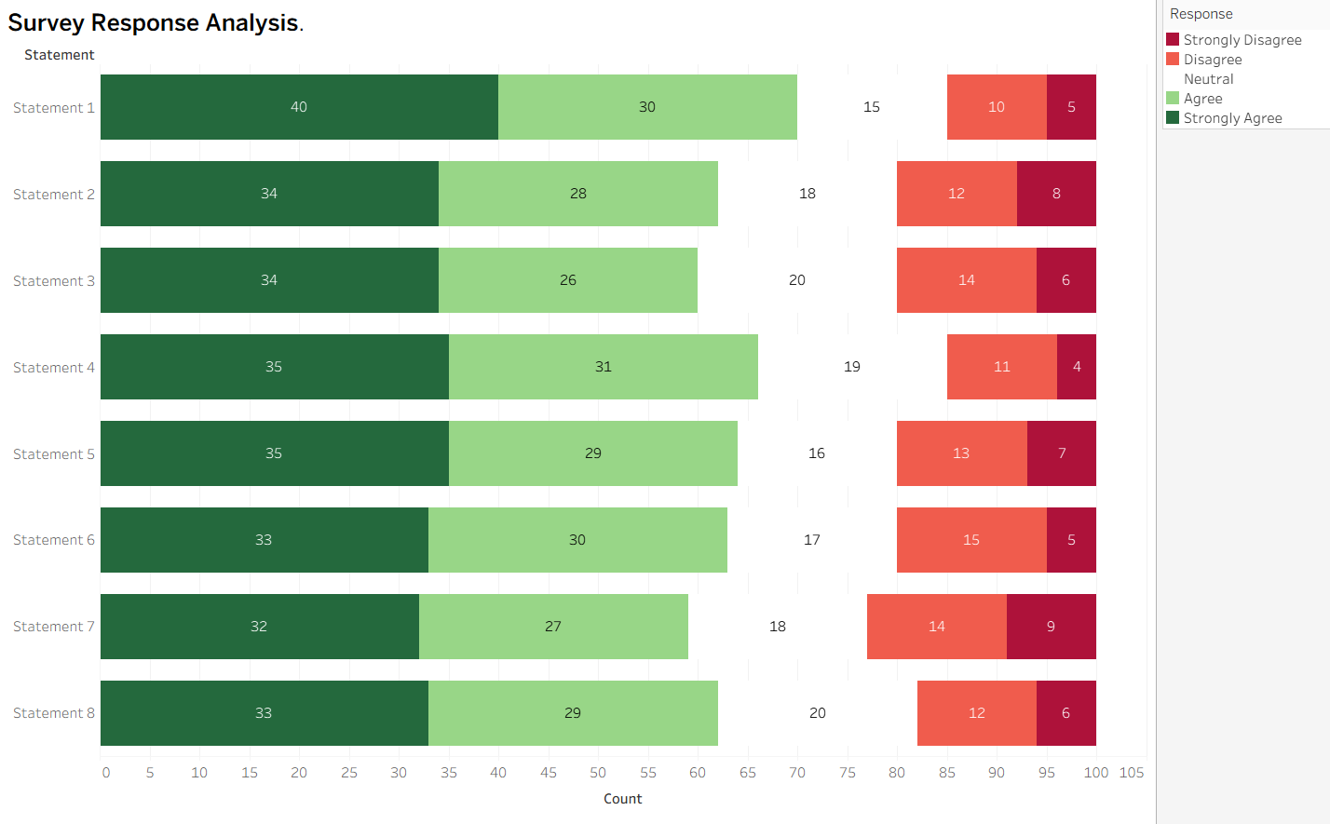
Conclusion
The Horizontal Stacked Bar Chart is an effective visualization for ordinal survey data because it maintains the natural ordering of response categories and enables meaningful comparison across multiple statements. The use of appropriate aesthetic mappings and a diverging colour scale improves clarity, interpretation and overall effectiveness of the visualization.

Problem 13 (10 Marks)
Scenario
A retailer wants to visualize sales data that has a strong day-of-week cyclical pattern (for example, sales spike every Saturday) across an entire year.

Aim
To analyse the weekly sales pattern and design a visualization that clearly highlights the recurring sales cycle across the days of the week.

Answer (a)
The most appropriate design for this scenario is a Circular (Polar) Chart, as it naturally represents repeating cycles such as days of the week. Since Tableau does not provide a built-in polar chart, a Weekly Sales Line Chart is implemented to demonstrate the same cyclical pattern while maintaining the chronological order of the days.

Axis and Aesthetic Mapping
Variable | Aesthetic Mapping
Day of Week | X-axis (Columns)
Sales | Y-axis (Rows)
Sales Trend | Line
Sales | Data Labels
In the proposed circular design, the Day of Week would be represented on the angular (circular) axis, while Sales would be represented on the radial axis. The line connects the sales values to highlight the weekly cycle, and data labels display the exact sales values for each day.

Answer (b)
A circular (polar) layout emphasizes repeating patterns because the end of one week naturally connects to the beginning of the next week. This continuous arrangement makes recurring peaks and troughs much easier to identify than a standard linear Cartesian chart.
From the Tableau visualization, sales increase gradually from Monday to Friday, reach their highest value on Saturday, and then decrease slightly on Sunday. This clearly indicates that Saturday consistently records the highest sales, demonstrating a strong weekly sales cycle.
Compared with a standard line chart spanning an entire year, a circular design reduces visual clutter and enables viewers to recognize recurring weekly behaviour more quickly.

Answer (c)
Before constructing the visualization, the sales data should be grouped by Day of Week.
This data preparation step combines all occurrences of each weekday throughout the year and calculates the average or total sales for each day. Grouping the data removes unnecessary daily variations and highlights the underlying weekly sales pattern.
This preprocessing step ensures that the visualization accurately represents the recurring sales cycle and makes comparison between weekdays easier and more meaningful.

Result
The Tableau visualization clearly illustrates the weekly sales trend. Sales gradually increase during the week, reach their maximum value on Saturday, and decrease slightly on Sunday, confirming the existence of a strong and consistent weekly sales cycle.
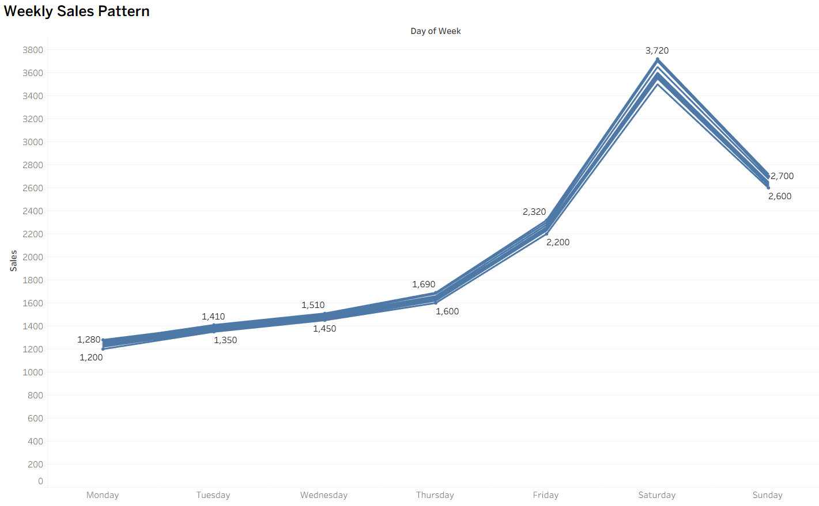

Conclusion
The proposed visualization effectively represents the retailer's weekly sales pattern by arranging the days in chronological order and highlighting changes in sales throughout the week. Grouping the data by day of the week allows recurring sales trends to be identified easily. Although Tableau does not directly support circular (polar) charts, the implemented Weekly Sales Line Chart successfully communicates the same cyclical behaviour and provides meaningful insight into weekly sales performance.

ASSESSMENT RUBRIC
AT3 — Visualization Design Exercise
CO1 · BT3: Apply ·
This rubric is used to assess student responses to the AT3 Visualization Design Exercise problems, in which students design and justify a complete visualization (chart type, aesthetic mappings, scales, coordinate systems, and/or color scheme) for a given dataset or design brief.

Criteria | Weightage | Level 4 – Exemplary | Level 3 – Proficient | Level 2 – Developing | Level 1 – Beginning
Understanding of Concepts | 25% | Demonstrates thorough, accurate understanding of chart types, aesthetic mappings, scales, coordinate systems, and color scales, and correctly identifies which apply to the given design scenario. | Good understanding of the relevant design concepts, with only minor gaps in selecting appropriate chart types, aesthetic mappings, or scales. | Basic understanding of design concepts, but with some misconceptions about appropriate chart types, aesthetics, or scales for the scenario. | Poor understanding of core design concepts; proposes chart types or mappings that are fundamentally unsuited to the data.
Explanation | 25% | Provides detailed, well-reasoned justification for every design decision, explicitly connecting each choice to the properties of the data and the scenario. | Provides clear justification for design decisions, with adequate reasoning for most sub-questions. | Justification is limited or superficial; design choices are stated without sufficient reasoning. | Little or no justification provided; design choices appear arbitrary or unexplained.
Application | 20% | Effectively applies visualization design principles to produce a complete, appropriate, and well-reasoned design solution for the specific scenario. | Applies design principles to produce an appropriate solution, with only minor errors or missed refinements. | Limited application of design principles; the proposed design partially addresses the scenario but has notable weaknesses. | Fails to apply appropriate design principles; the proposed design does not suit the scenario or data.
Organization | 15% | The design proposal is clearly structured, addressing each sub-question (a, b, c) in a logical sequence with coherent flow throughout. | The proposal is organized and addresses each sub-question, with only minor issues in flow or clarity. | Basic structure; sub-questions are addressed but the proposal lacks clarity or a logical sequence. | Poorly organized; the proposal is incoherent, and sub-questions are left unaddressed or answered out of order.
Accuracy | 10% | All design choices — chart type, aesthetic mapping, scale, coordinate system, and/or color scheme — are completely accurate and well-suited to the data. | Mostly accurate design choices, with only minor omissions or a small error in one part of the proposal. | Partially correct; some design elements are missing, mismatched to the data, or incorrect. | Design choices are largely incorrect or inappropriate, with major gaps in matching the visualization to the data.

Scoring Guide
For each criterion, award a performance level (1–4) based on the descriptors above. Multiply the level achieved (as a percentage of 4, i.e., Level 4 = 100%, Level 3 = 75%, Level 2 = 50%, Level 1 = 25%) by the criterion's weightage, then sum across all five criteria to obtain the total score out of 100%.

Faculty In-charge | Course Coordinator | Head of Department
Signature: _______________ | Signature: _______________ | Signature: _______________
Date: ___________________ | Date: ___________________ | Date: ___________________

